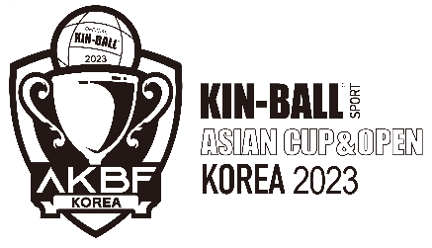
Letter of Intention

The purpose of this form is to predict the participating teams by country.
- Submitter information
Nationality or Submitter
Participation category | □ | AC / National Team Men
 | □ | AC / National Team Women
 | □ | AO / Mix gender pro club

Organization will recognize this form as a document confirming the participation of the country or team.
And this form includes a commitment to pay the registration fee at the two-day event on November 4-5, 2023.

Team registration must be submitted by August 30th.
Team registration fees must be paid by September 30th.
- Intent information
Category | Per | Fee | Number of teams | Total price
AC / National Team Men | Team | 700,000 KRW
AC / National Team Women | Team | 700,000 KRW
AO / Mix gender pro club | Team | 450,000 KRW

- Contact details
Surname
First Name
Telephone
E-mail

Date
____________________________
Signature of national federation or club team representative
________________________________________________________________

